MOTHERS DAY BUFFET

SUNDAY MAY 12TH, 2024
SEATINGS AVAILABLE: 11:00AM, 1:30PM, 4:00PM *RESERVATION ONLY*

Call the Green Horizon Grill at (717) 624-0947 to book your reservations today!

33 - ADULT 19 – 10 & UNDER

CARVING STATION:
PRIME RIB & HONEY GLAZED HAM

ROASTED TURKEY BREAST W/ GRAVY HOUSE MADE MEATLOAF
CHICKEN TENDERS
HOUSE MADE STUFFING
HOUSE MADE MASHED POTATOES
MIXED VEGETABLE MEDLEY

SEASONED CORN
FRESH SEASONED GREEN BEANS
ITALIAN PASTA SALAD
FRESH BAKED ROLLS
APPLE FETA TOSSED SALAD
SOUP: SPINACH & CHEESE TORTELLINI
ASSORTED CAKES, CHEESECAKES
AND PIES

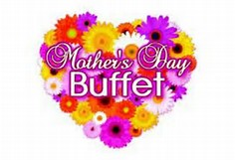
Price does not includes soft drinks, sales tax, or gratuity

